SRWE Final Packet Tracer Assessment
R1, S1, S2: VLANs, trunking, EtherChannel, port security, DHCP and dual-stack routing
This document goes through the assessment part by part, in the order the instructions lay it out. The screenshots that exist so far are placed where they belong: Part 1's physical build, the native VLAN and EtherChannel work on S2 from Part 3, and R1's default routes from Part 4. The parts that have no screenshot yet (SSH hardening, subinterfaces, port security, DHCP, host addressing) are written out as commands to run, using the exact values the assessment gives and a placeholder wherever it depends on an addressing table or VLAN table that was not included with the instructions.

1. What the assessment asks for
One router (R1) and two switches (S1, S2) support two VLANs of hosts plus a management VLAN, with dual-stack IPv4/IPv6 throughout. The four parts are built in order: physically cable the rack, harden and SSH-enable every device, build the VLAN/trunk/EtherChannel/port-security layer, then bring up routing, DHCP and the hosts.
Part | What it covers
1 | Build the physical topology: rack the devices, place the PCs, cable them.
2 | Initial settings and hardening on R1, S1, S2: hostname, banner, passwords, SSH, then R1's loopback and subinterfaces, then the switch management SVIs.
3 | VLANs and trunking on S1/S2 (native VLAN 6), a Layer 2 EtherChannel between them, static access ports with port security, and unused ports parked in VLAN 5.
4 | R1 default routes to Lo0, two DHCP pools, and host addressing (DHCP for IPv4, static for IPv6).

VLANs referenced in the instructions and the screenshots
The assessment refers to a VLAN table that was not included with the text supplied for this document. What can be pinned down from the instructions and from the terminal captures:
VLAN | Used for | Source
2 | S1's host access port; DHCP pool CCNA-A | Part 3 Step 3a, Part 4 Step 2
3 | S2's host access port; DHCP pool CCNA-B | Part 3 Step 3b, Part 4 Step 3
4 | Management SVI (assumed — see note below) | The S2 screenshot shows Interface Vlan4 tracking the trunk ports
5 | Parking VLAN for unused, shut-down ports | Part 3 Step 3d
6 | Native VLAN on the F0/1, F0/2 (and, on S1, F0/5) trunks | Part 3 Step 1b, confirmed in the S2 screenshots

The Management VLAN number is not stated outright anywhere in the instructions; it is inferred here as VLAN 4 because the S2 screenshots show Line protocol on Interface Vlan4 going down and back up in step with the F0/1/F0/2 ports, which is what happens when an SVI's only path up is a port that just flapped. Confirm this against the actual VLAN table before relying on it.

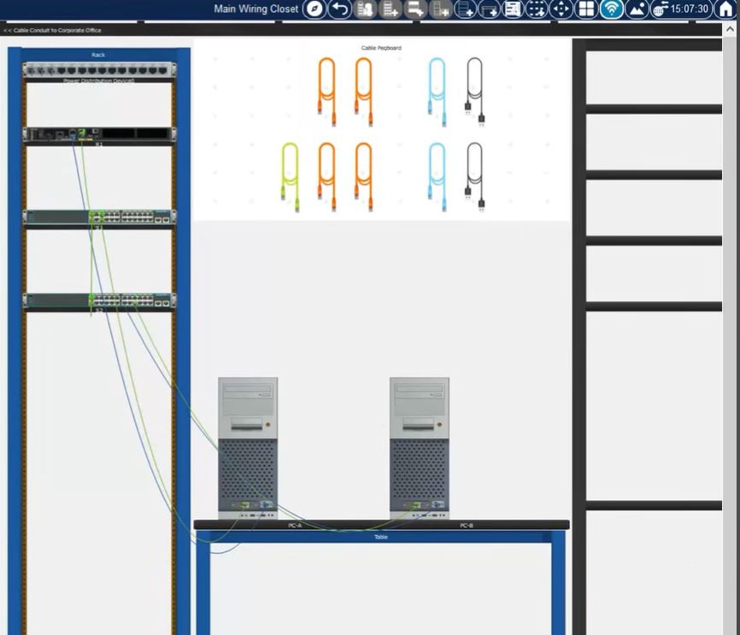
2. Part 1: Build the network
Figure 1. Main Wiring Closet: rack (PDU, R1, S1, S2), cable peg board, and PC-A/PC-B on the table.
The rack holds the Power Distribution Device, R1, and the two switches, S1 above S2. PC-A and PC-B sit on the table and cable up into the rack. The peg board on the right is just the cable inventory Packet Tracer shows in Physical Mode; the colors of the patch cords do not need to match anything — they are not tied to VLAN colors or to straight-through vs. crossover wiring.

3. Part 2: Initial settings and hardening

R1, S1 and S2: common hardening
All three devices get the same shape of hardening, using the values the assessment specifies exactly and everything else at the operator's discretion:
no ip domain-lookup
hostname <R1 | S1 | S2>
banner motd "Unauthorized access is prohibited"
security passwords min-length 10
enable secret <a password of at least 10 characters>
service password-encryption
line console 0
password <console password>
login
no ip domain-lookup stops the device from treating a mistyped command as a hostname and trying to resolve it, which is why a typo otherwise hangs for a while before reporting an error. security passwords min-length 10 should be set before the enable secret and any line passwords are typed, so that the 10-character minimum is actually enforced on them rather than just happening to be met.

SSH, all three devices
username admin secret admin1pass
ip domain-name ccna-ptsa.com
crypto key generate rsa ! modulus 1024
ip ssh version 2
line vty 0 4
login local
transport input ssh
- The account is admin with the encrypted secret admin1pass, exactly as given in Part 2 Steps 1c and 3c.
- The domain name has to be set, and the RSA key generated, before SSH will run; the 1024-bit modulus is the value the assessment specifies.
- ip ssh version 2 is the "more secure version of SSH" the instructions ask for.
- login local plus transport input ssh means: authenticate against the local user database, SSH only, no Telnet, on both the router and both switches.

R1: loopback and subinterfaces
Loopback0 carries an IPv4 and an IPv6 address from the addressing table (not included with the instructions supplied, so shown here as a placeholder):
interface loopback 0
ip address <Lo0 IPv4> <mask>
ipv6 address <Lo0 IPv6>
The physical interface toward the switches needs ipv6 unicast-routing in global configuration before any interface can forward IPv6, plus one subinterface per VLAN in the trunk's allowed list (2, 3, 4 and the native VLAN 6):
ipv6 unicast-routing
interface g0/0/1
no shutdown
interface g0/0/1.2
encapsulation dot1Q 2
description VLAN 2 hosts
ip address <VLAN2 IPv4> <mask>
ipv6 address <VLAN2 IPv6>/<prefix>
ipv6 address fe80::1 link-local
interface g0/0/1.3
encapsulation dot1Q 3
description VLAN 3 hosts
ip address <VLAN3 IPv4> <mask>
ipv6 address <VLAN3 IPv6>/<prefix>
ipv6 address fe80::1 link-local
interface g0/0/1.4
encapsulation dot1Q 4
description Management VLAN
ip address <VLAN4 IPv4> <mask>
ipv6 address <VLAN4 IPv6>/<prefix>
ipv6 address fe80::1 link-local
interface g0/0/1.6
encapsulation dot1Q 6 native
description Native VLAN
ip address <VLAN6 IPv4> <mask>
ipv6 address <VLAN6 IPv6>/<prefix>
ipv6 address fe80::1 link-local
Every addressed subinterface reuses fe80::1 as its link-local address, exactly as Part 2 Step 2b asks; that is safe because link-local addresses only have to be unique on their own link, and each subinterface is its own link. The physical numbering above (g0/0/1) is a placeholder for whichever Gigabit interface actually carries the trunk to the switches on this topology — confirm it against the real device before typing these in.

S1 and S2: management SVI
interface vlan <management VLAN>
ip address <SVI IPv4> <mask>
no shutdown
ip default-gateway <R1 subinterface address on that VLAN>
The default gateway is required for Part 2 Step 4b: without it, the SVI can answer on its own subnet but a management session from another network has nowhere to route its reply.

4. Part 3: VLANs, trunking and EtherChannel
This is the part the screenshots cover in the most detail: getting the S1–S2 trunk onto native VLAN 6, then bundling it into an EtherChannel. The two screenshots below show the exact same command sequence on S2 — one captured directly on the switch, the other through a Telnet/console session opened from PC-B — confirming both access paths agree on the switch's state.

Trunk ports and the native VLAN
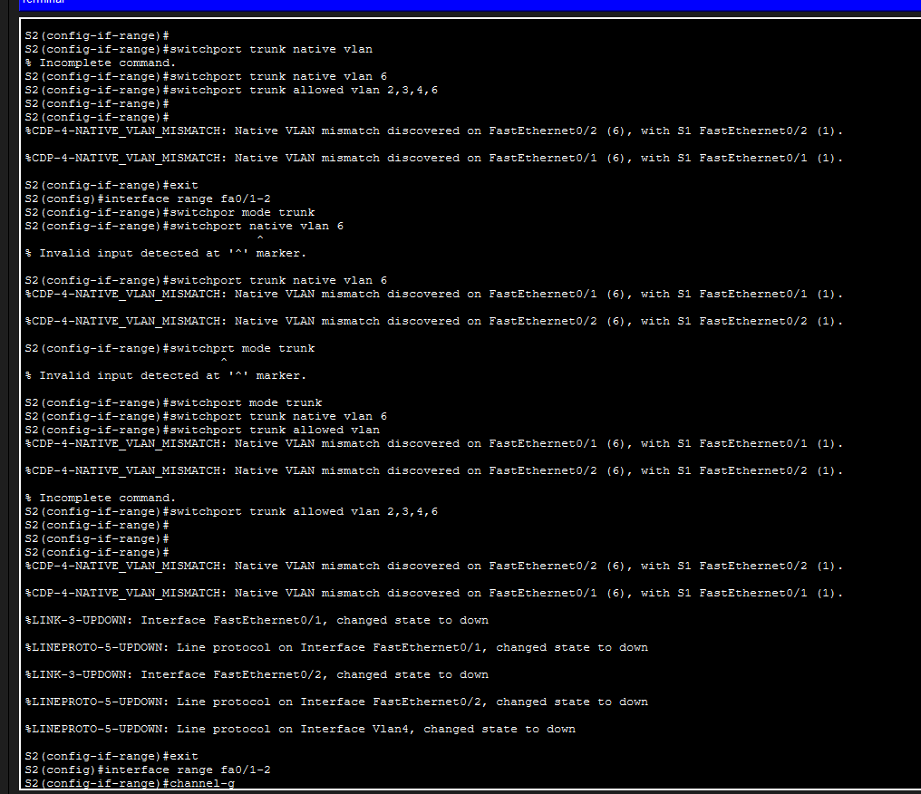
Figure 2. S2, direct console: setting the trunk native VLAN and allowed list on F0/1–F0/2, and the CDP mismatch that follows.
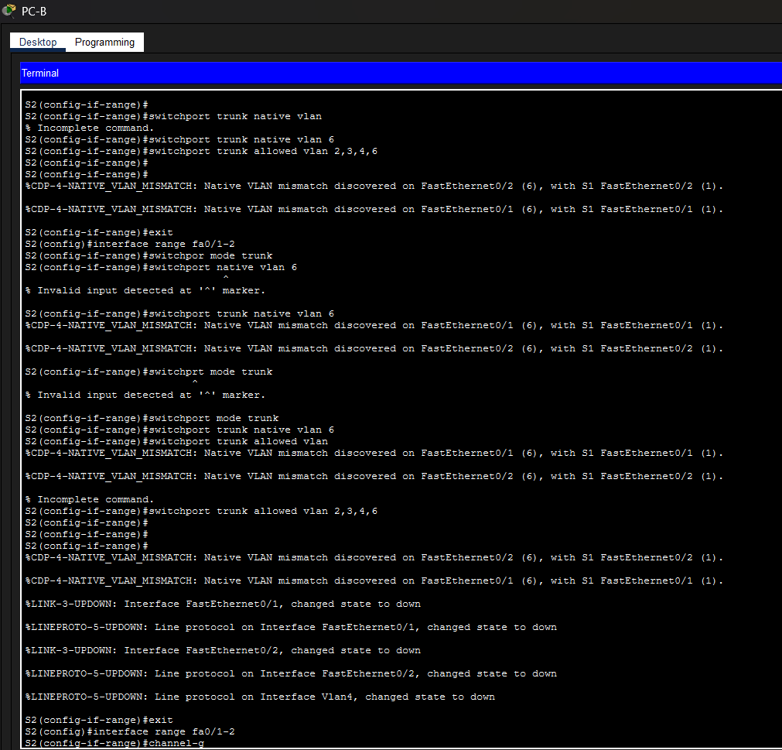
Figure 3. The same S2 session, viewed through PC-B's Telnet/console access — identical output confirms the state either way.
Reading through what happens on S2:
- switchport trunk native vlan with no number is rejected as an incomplete command; the corrected form is switchport trunk native vlan 6.
- The moment VLAN 6 is set as the native VLAN on S2's F0/1 and F0/2, CDP reports a mismatch on both: %CDP-4-NATIVE_VLAN_MISMATCH ... FastEthernet0/2 (6), with S1 FastEthernet0/2 (1). S1 is still on the default native VLAN, 1. A native VLAN mismatch is not cosmetic — untagged traffic on that link lands in a different VLAN depending which end receives it — and it has to be fixed on both switches, not just S2.
- switchpor mode trunk and switchprt mode trunk are both plain misspellings of switchport; IOS rejects them at the exact character where parsing breaks, shown by the ^ marker.
- switchport trunk allowed vlan with nothing after it is the same "incomplete command" pattern again; the corrected line is switchport trunk allowed vlan 2,3,4,6.
- The mismatch message keeps repeating on every CDP refresh because nothing on S1 has changed yet — it will keep appearing until S1's F0/1/F0/2 (or its own port-channel) is also set to native VLAN 6.
- Re-applying switchport mode trunk briefly drops both physical links (%LINK-3-UPDOWN ... down), which also pulls down VLAN 4's line protocol since that SVI's path up runs through one of these ports. This flap is normal and settles once the ports come back up.

EtherChannel and the resulting STP block
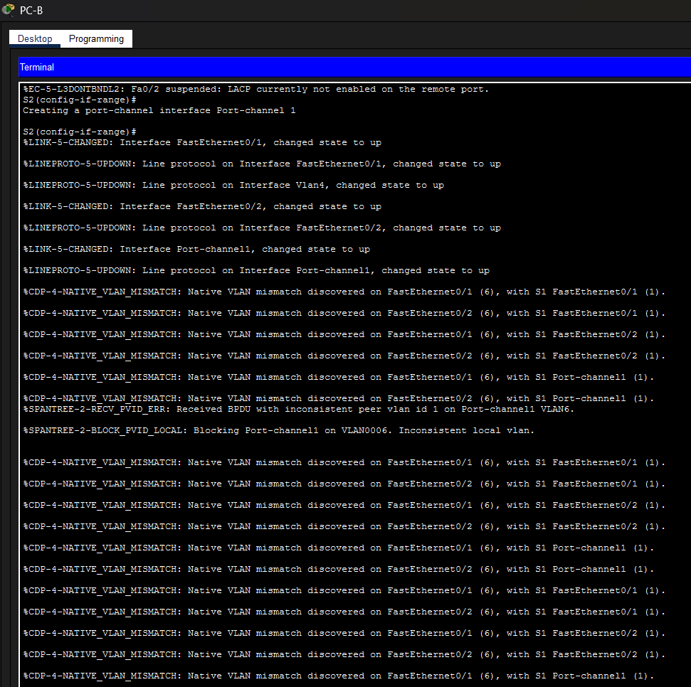
Figure 4. S2: LACP suspension while S1 catches up, Port-channel1 forming, and STP blocking it once the native VLAN mismatch reaches the bundle.
With F0/1–F0/2 selected as a range, channel-group 1 mode active starts LACP negotiation:
- %EC-5-L3DONTBNDL2: Fa0/2 suspended: LACP currently not enabled on the remote port is expected the moment only one side has been configured; it clears once S1 also runs channel-group 1 mode active (or passive) on its matching ports.
- Port-channel1 is created, both members come up, and then Port-channel1 itself comes up — the bundle formed correctly at Layer 1/2.
- The native VLAN mismatch messages now appear once per member port and once more for Port-channel1 itself, since CDP checks the logical interface as well as each physical one.
- %SPANTREE-2-RECV_PVID_ERR: Received BPDU with inconsistent peer vlan id 1 on Port-channel1 VLAN6 followed by %SPANTREE-2-BLOCK_PVID_LOCAL: Blocking Port-channel1 on VLAN0006 is the direct consequence: Port-channel1 is receiving BPDUs tagged with native VLAN 1 while S2 expects 6 on that link, so spanning tree blocks the port-channel on VLAN 6 to avoid a loop or a VLAN leak between mismatched native VLANs.
This block will not clear on its own. It needs the same fix as the CDP mismatch: set native VLAN 6 on S1's side of the trunk (and, once the channel exists there too, on S1's Port-channel1 interface). That is the next command to run on S1 and is listed as an open item in section 6.

Access ports and port security
Once the trunk and channel are stable, each switch gets one static access port for its host:
! S1, host access port
interface <S1 port to PC-A>
switchport mode access
switchport access vlan 2
switchport port-security
switchport port-security maximum 3
! S2, host access port
interface <S2 port to PC-B>
switchport mode access
switchport access vlan 3
switchport port-security
switchport port-security maximum 3
switchport port-security has to be turned on before maximum or any other port-security sub-command will take effect. The instructions only ask for a maximum of three learned addresses; they do not specify sticky learning or a particular violation action, so the addresses will age out as dynamically-learned entries and a fourth address will trigger the default violation mode, shutdown (the port goes into err-disabled).

Unused ports
interface range <every port not otherwise used>
switchport mode access
switchport access vlan 5
shutdown
description Unused port, administratively shut down

5. Part 4: Host support

Default routes to Loopback0
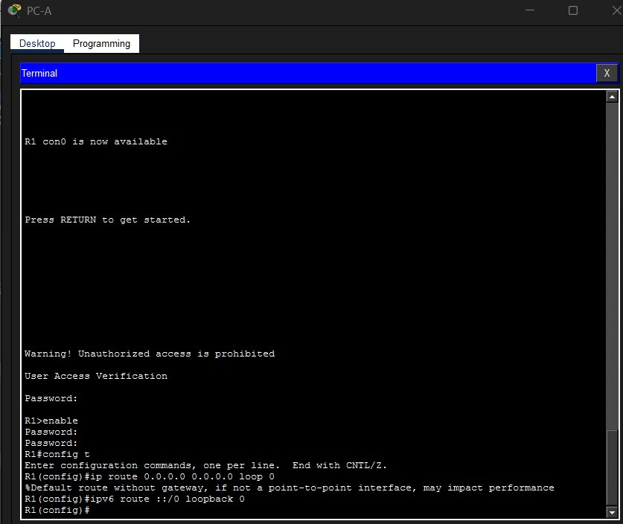
Figure 5. R1 console via PC-A: login, enable, and the default IPv4/IPv6 routes pointed at Loopback0.
- ip route 0.0.0.0 0.0.0.0 loop 0 and ipv6 route ::/0 loopback 0 both point the default route at Loopback0 rather than a real next hop, exactly as Part 4 Step 1 asks.
- The IPv4 command draws a warning: "Default route without gateway, if not a point-to-point interface, may impact performance." A loopback is a software interface that never goes down, so a route pointed at it stays in the table permanently and anything actually sent there is effectively dropped; IOS is only warning that this isn't a real forwarding path, which matches the intent of the assessment step (satisfying the routing-table requirement rather than building working default connectivity). The IPv6 version accepts the same kind of route without printing a warning.

DHCP pools
Each pool covers a VLAN's subnet except its last 10 usable addresses, which stay excluded for static use (the SVIs, the router subinterface, and anything else fixed on that VLAN):
ip dhcp excluded-address <VLAN2 network start> <VLAN2 address 10-from-the-top minus 1>
ip dhcp pool CCNA-A
network <VLAN2 network> <mask>
default-router <R1 g0/0/1.2 address>
domain-name ccna-a.net

ip dhcp excluded-address <VLAN3 network start> <VLAN3 address 10-from-the-top minus 1>
ip dhcp pool CCNA-B
network <VLAN3 network> <mask>
default-router <R1 g0/0/1.3 address>
domain-name ccna-b.net
The pool itself only defines what it hands out; the exclusion is what keeps it from also offering the last 10 addresses that Step 2a and 3a reserve. Once the real VLAN 2 and VLAN 3 subnets are known, the excluded range is everything from the network address up through the address just before the last 10 usable hosts.

Host addressing
- 124-1-style hosts on VLAN 2 and VLAN 3: set IPv4 to DHCP.
- IPv6 is static on every host: the global unicast address and default gateway come from the addressing table, matching the pattern used in the ITN and SRWE practice labs done earlier — the gateway is the router subinterface's link-local address, fe80::1.

6. Things to check or finish
- S1 still needs native VLAN 6. The screenshots only show S2's side. Until switchport trunk native vlan 6 (and the matching allowed list) is applied to S1's F0/1, F0/2 — and, once the channel exists, to S1's Port-channel1 — the CDP mismatch and the STP block on Port-channel1 will persist.
- Confirm the Management VLAN number. This document assumes VLAN 4 from the Interface Vlan4 line in the S2 screenshots. Check it against the actual VLAN table.
- S1's F0/5 trunk. The instructions call for F0/5 to be a trunk on S1 only (not part of the EtherChannel). No screenshot covers this yet.
- Fill in the addressing table values for Loopback0, the four R1 subinterfaces, both switch SVIs, and the two DHCP pool subnets — none of these were included with the assessment text supplied, so section 3 and this section use placeholders.
- Port security violation mode and sticky learning were left at the IOS defaults since the instructions do not specify either; decide if sticky or a non-default violation action (protect/restrict) is wanted.
- Banner wording, console/VTY passwords, and the enable secret were left as placeholders above the 10-character minimum; pick any value that satisfies it.
- Save every device with copy running-config startup-config once each part is verified.

7. Error reference
Device | Message | Cause | Fix
S2 | % Incomplete command (switchport trunk native vlan) | No VLAN ID given | Add the VLAN ID, e.g. ... native vlan 6
S2 | % Incomplete command (switchport trunk allowed vlan) | No VLAN list given | Add the list, e.g. ... allowed vlan 2,3,4,6
S2 | % Invalid input (switchpor mode trunk, switchprt mode trunk) | Misspelled switchport | switchport mode trunk
S2 | %CDP-4-NATIVE_VLAN_MISMATCH | S2 = VLAN 6, S1 still = VLAN 1 on the same trunk | Set native VLAN 6 on S1 as well
S2 | %SPANTREE-2-RECV_PVID_ERR / BLOCK_PVID_LOCAL on Port-channel1 | Native VLAN mismatch reaches the bundled link | Same fix — native VLAN 6 on S1
S2 | %EC-5-L3DONTBNDL2 (Fa0/2 suspended) | LACP not yet enabled on S1's matching port | Configure channel-group 1 mode active on S1 too
R1 | Default route without gateway ... may impact performance | Static route points at Loopback0, not a next hop | Expected for this step; not an error to fix

8. Verification commands
Command | What to look for
show cdp neighbors detail | No more native VLAN mismatch once S1 is fixed
show etherchannel summary | Port-channel1 shows SU, both members show P
show spanning-tree vlan 6 | Port-channel1 forwarding, not blocked, once the mismatch is resolved
show interfaces trunk | F0/1, F0/2 (and F0/5 on S1) trunking, native VLAN 6, allowed list 2,3,4,6
show port-security interface <port> | Maximum 3, current count, violation mode
show ip dhcp binding | Leases handed out only from within the last-10 range on each VLAN
show ip route / show ipv6 route | Default routes present, pointing at Loopback0
show ip ssh | SSH enabled, version 2, 1024-bit key, on R1, S1 and S2
ping / ping ipv6 | Between hosts, to both switch SVIs, and to R1's subinterfaces

